### React Components Part 1

#### Objectives and Outcomes

In this exercise you will add the first component to your React application and update its view using JSX. At the end of this exercise you will be able to:

* Add components to your React application
* Use JSX to define the views of your component.

#### Adding a Navigation Component

* First, download the images.zip file provided above and then unzip the file. Create a folder named assets in the public folder. Move the resulting images folder containing some JPG files to the React project's public/assets folder. These image files will be useful for our exercises.
* Next, add a new folder named components in the src folder, and create a new file named Navigation.js in this folder.
* Add the code to Navigation.js:

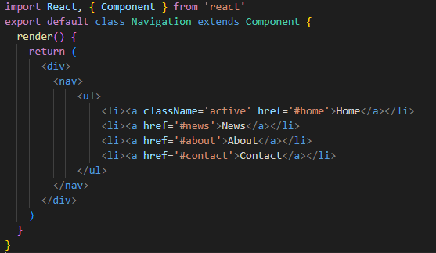

* Open App.css file and update it for navigation display.
* Next, open App.js file and update it as follows:

import './App.css';

import Navigation from './components/Navigation';

function App() {

  return (

    <div className='App'>

      <Navigation/>

    </div>

  );

}

export default App;

* Screen display:



#### Adding a Players Component

* Create a new file named Players.js in *src* folder.
* Add the code to Players.js:

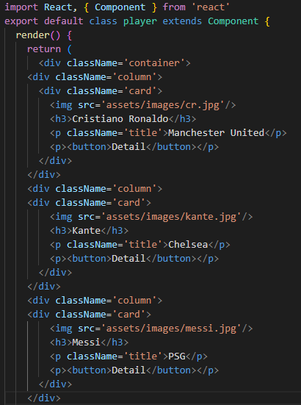

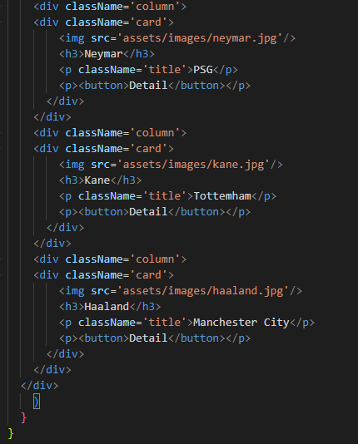

* Open App.css file and update it for Players display.
* Next, open App.js file and update it as follows:

import './App.css';

import Navigation from './components/Navigation';

import Player from './components/player';

function App() {

  return (

    <div className='App'>

      <Navigation/>

       <Player/>

    </div>

  );

}

export default App;

* Screen display:

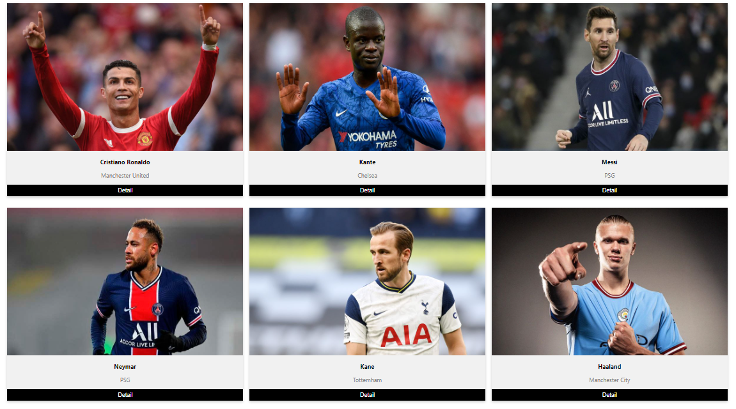

#### Adding a Footer Component

* Create a new file named Footer.js in *src* folder.
* Add the code to Footer.js and App.css.
* Update the App.js for using Footer component.
* Screen display:



#### Final result:

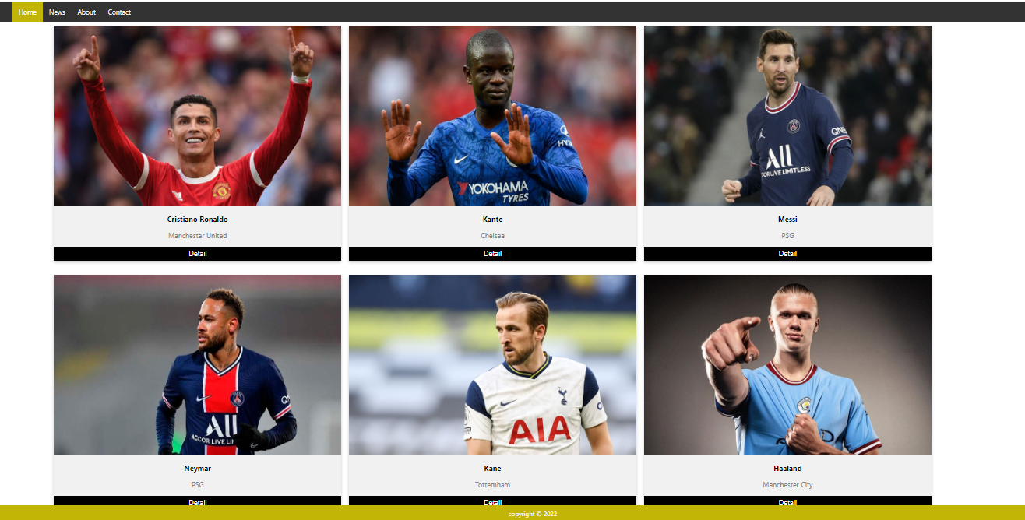

* Save all changes and do a Git commit with the message "Components Part 1".

#### Conclusions

In this exercise we added a new component to our React application.